CSIS3280-01 Assignment 4 Winter 2015
Due Date: Apr. 2nd/2015
You can do this assignment with ONE partner(not 35)

This assignment involves a number of PHP programs, accessing various mySQL databases. The following describes the functionality of the various programs. You can use “cookies” for this assignment BUT NOT sessions.

You are in charge of writing for a game purchasing web site. The following are the various web scripting programs you need to write for this site.

gameBuyLogin.php

This is the opening program for your site. Note, lastname can have up to 20 chars MAX, BUT the password MUST be 7 chars. in length.

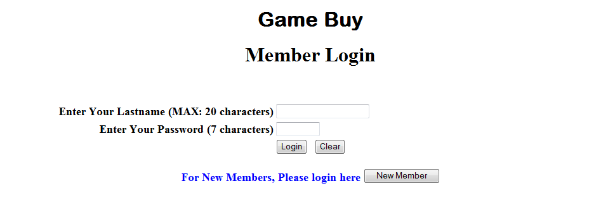

Note that this is a “sticky” form. If the user enters the wrong Lastname/Password combination, then it should

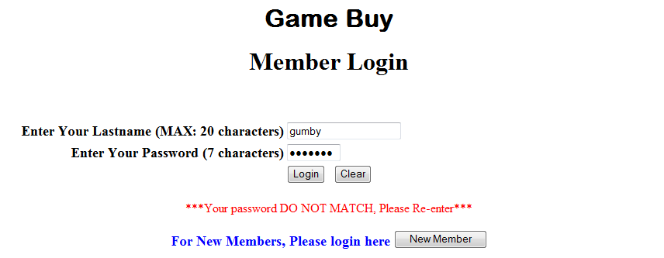

If the user enters the wrong length for lastname and/or password

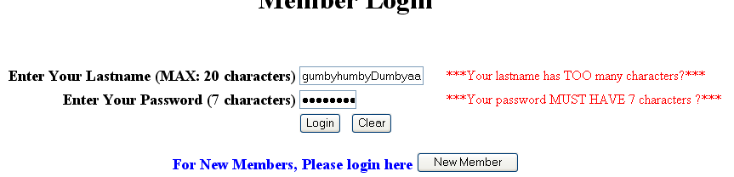

Finally, If the user did not enter anything in the text boxes and pressed the “submit” button, then:

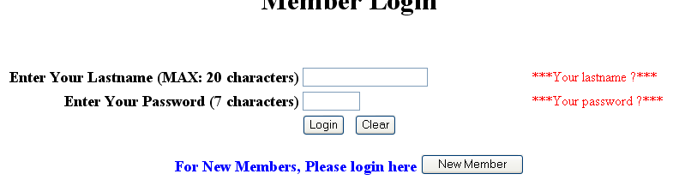

addNewCust.php
If you are a new member, click the “New Member” button, and it should take you to this program, which is also a “sticky” form. The following shows the main screen with some data entered (initially of course all the fields are blank):
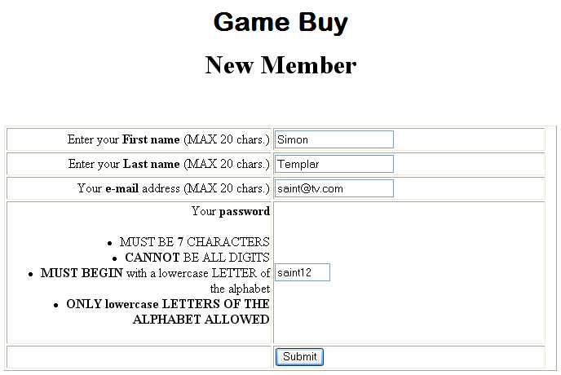

Note the restrictions on the data entries. The following shows the typical error messages if you violate any of the rules.

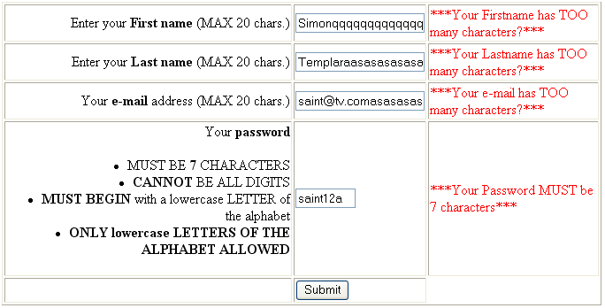

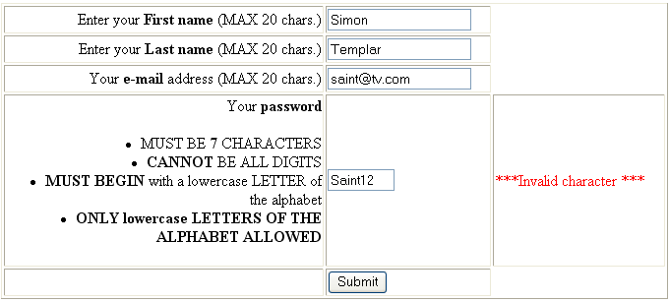

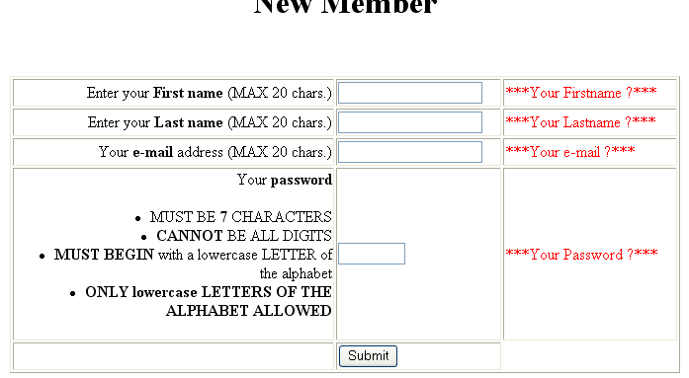

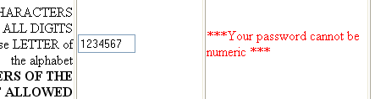

Now, assuming user Simon Templar has been processed and is now a member, if another user later on, tries to become a member, with the same lastname and password combination, then the following should appear:
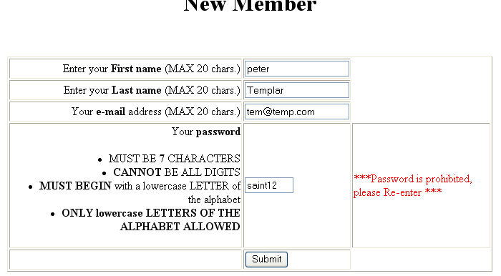

So, although he is a new member, but because of the same lastname/password combination, the password is “prohibited” (the reason is not given, as you may not want anybody to know there is already a person with that lastname/password combo). This user will need to re-enter a new password.

titleSrch.php

If the data is entered correctly, then after “submit” from “addNewCust.php or “login” from “gameBuyLogin.php”, it should go to this program and display the following (here assuming “Simon Templar” has either logged in or straight after “submit” from “addNewCust.php”:

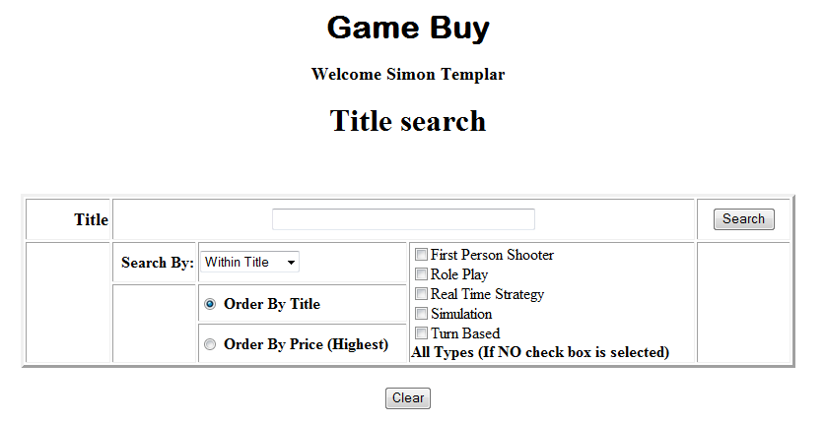

Note. 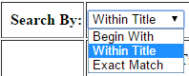 and “Within Title” is the default for the search criteria.

If the user clicks the “search” button, then it should invoke fetchDisplayGame.php and display all the available games falling under any genre , i.e.:

From fetchDisplayGame.php

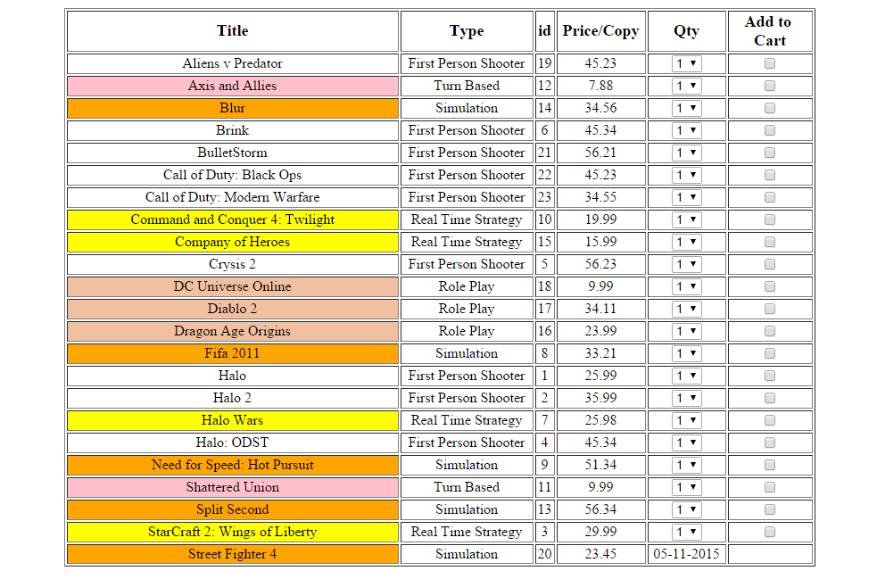

Note the different background colours when displaying the game titles for the different game types. The above is displayed in ascending game title sequence.

Also, notice the last game title “Street Fighter 4” is available at a later date, so it is not ready to be purchased, hence no “Qty” or “Add to Cart” is available for that title. Note, the date is displayed in MM/DD/YYYY format.

If the user clicks the browser “back” button it goes back to “titleSrch.php”. Now if the user entered say:
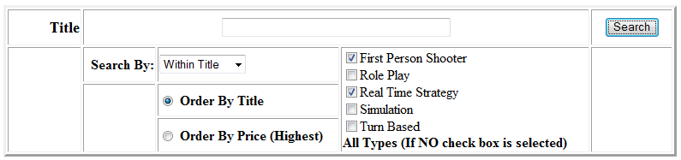
i.e. all games in the type as indicated in the check boxes, then “fetchDisplayGame.php” should display:

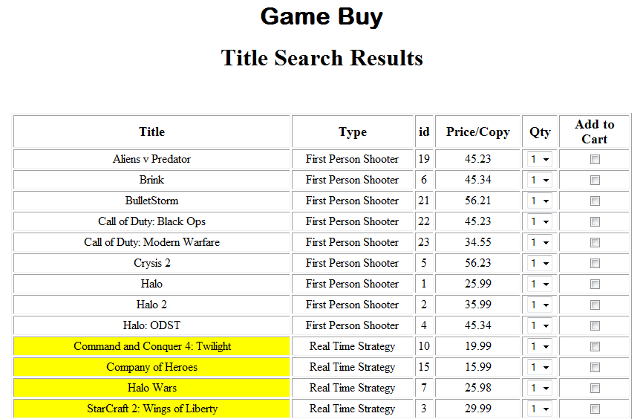

Note the game title is displayed in ascending sequence within their game type. The game type is in the sequence as shown in the Title Search screen (i.e. in this case all First Person Shooter games, then Real Time Strategy etc..)

If the user entered:
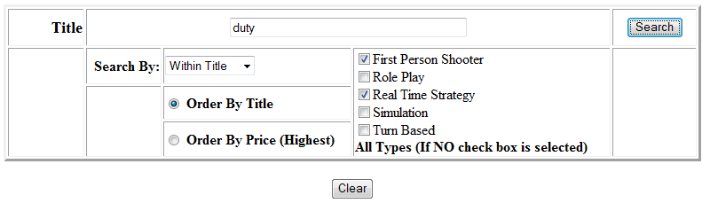

Then after search is clicked on, it should display all game titles with the word “duty” in it, but only within the First Person Shooter and Real Time Strategy genre. i.e:.

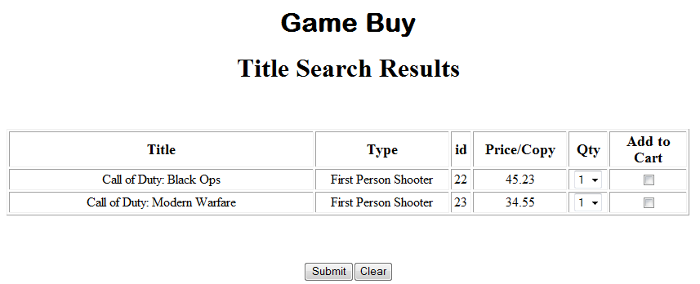
Note, in the above case there are no games with “duty” in the game title for Real Time Strategy type.

If the user entered:
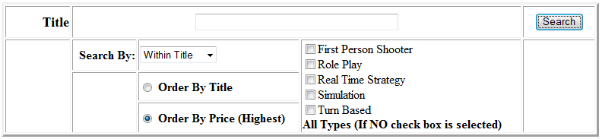
i.e. sort by Price, then the output should be:
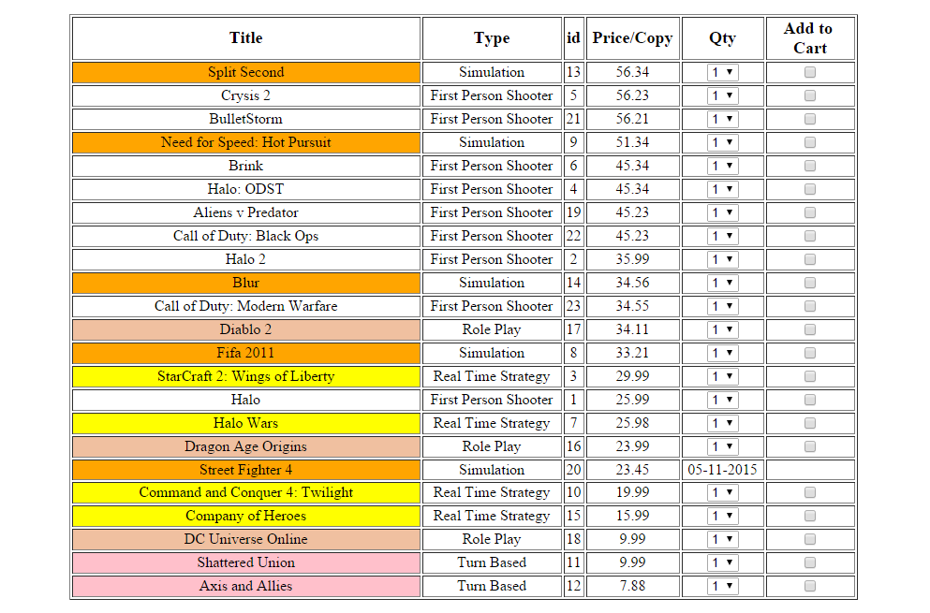

Note it is by descending sequence of price and if it is the same price, then by ascending sequence of title.

If there are no game titles fitting your search criteria, then upon clicking the “search” button, it should display:
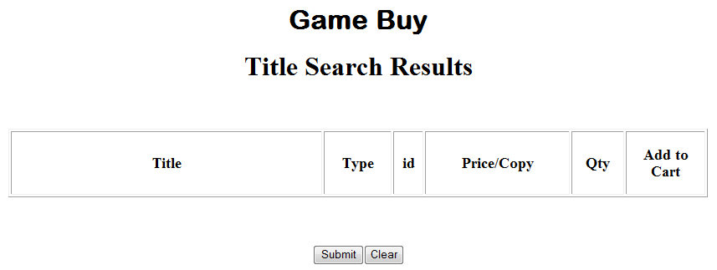

titleSrch.php

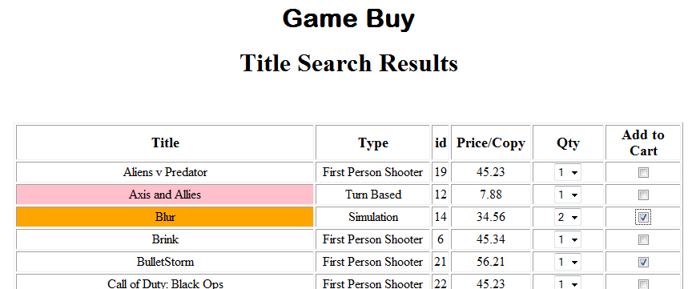
Assuming above is what is the result of your game search and you have selected the Qty you want AND have checked the appropriate “Add to Cart” check boxes.

Note: 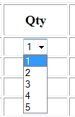

addOrderGame.php
When the submit button is clicked, this program should display the following (assuming the previous selections)

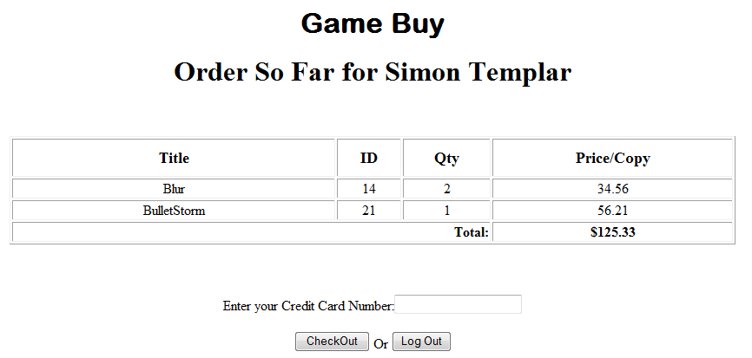

If was clicked on, but no credit card entered, then it should display:



processGameOrders.php
If a credit card is entered and button clicked, then processGameOrders.php will process the orders and display:
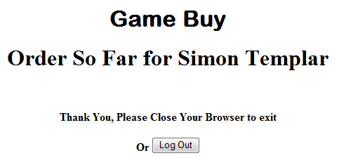

NOW, if the user “presses” the browser’s <back> button, you may see this again:

If this is so, and user re-enters the credit card and clicks , then it should display:
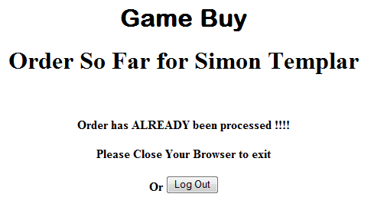

Assuming user “Simon Templar” clicks the browser back button and goes back to the search screen and makes the following selection:

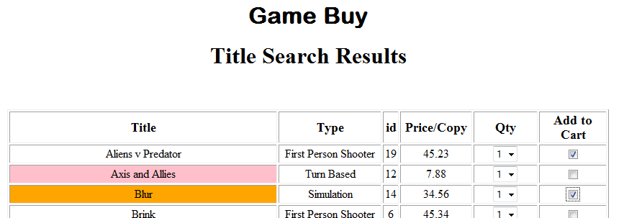
(And yes, the user can select “Blur” again. This type of situation will be the user’s responsibility)

And clicks “submit” which would then display:

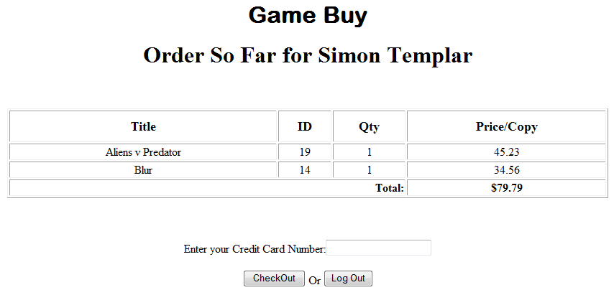
If a credit card is entered and the “Check Out” button is clicked, then:

If the user had selected the following titles and is now at the Checkout page:

If the user clicks (please see later for exact behavior of this button) without entering the credit card, but logs back in later, and makes his or her way back to the checkout page (without adding more game titles to the cart), it should display:

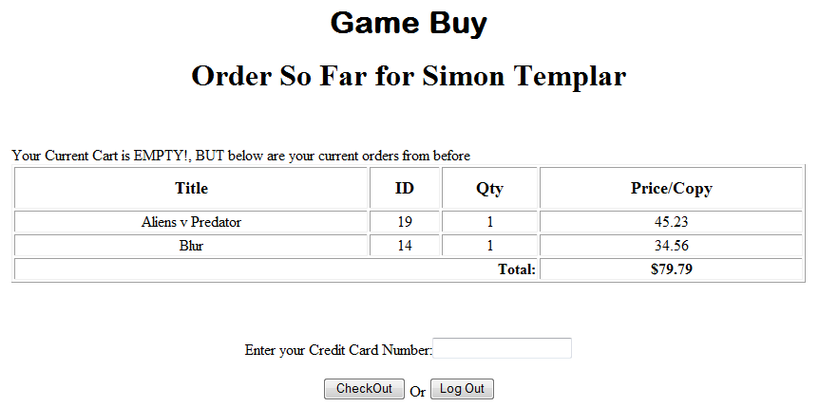

If the user does click the browser <back> button and selects the following:

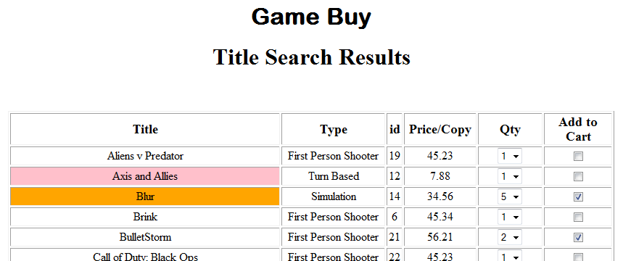

Then on clicking “Submit” it should display:

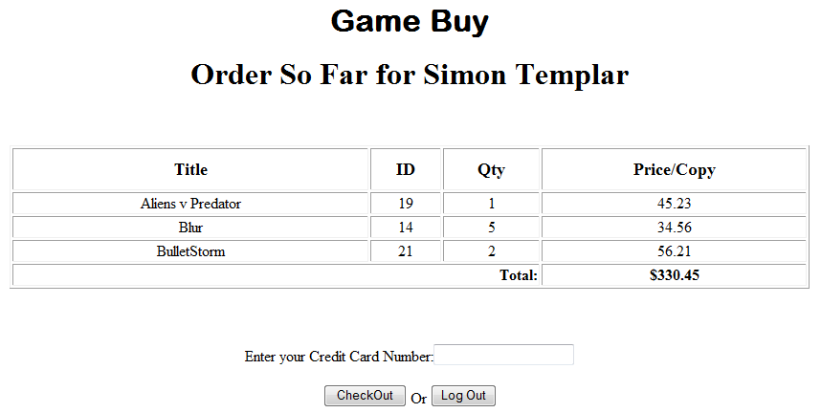

Note, “Aliens v Predator” is still there from before. For “Blur” the Qty is updated by the new amount. Any new game title is also added in (i.e “BulletStorm” in this case)

If the user has entered the credit card, checked out and logs back in later but makes no game selections, then when he or she makes it to the checkout, it should display:

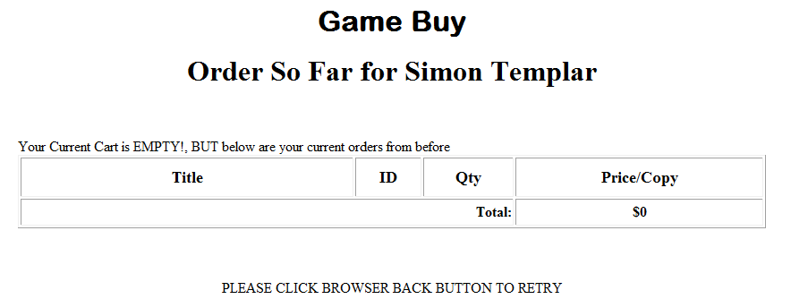

i.e. the “checkout” and “Log Out” button and credit card text box should NOT appear.

The Log Out button
In the previous screens you may have noticed the “Log Out” button. Whenever the user clicks this button, it should take the user back to the “Member Login” screen, i.e.

mySQL databases

The following is the main mySQL database to be used. (You can create these using “phpMyAdmin” or through the mySQL console).

This database will have the following tables and their corresponding fields.
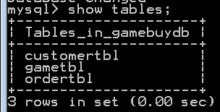

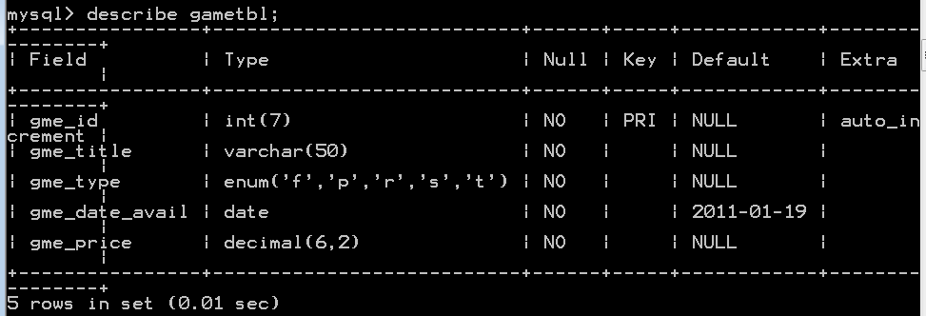
The above table will store the various game titles. The “gme_type” can have the single character as indicated above (f – first person shooter, p – role play, r – real time strategy, s – simulation, t – turn based ) Note, the gme_date_avail will need to be stored in YY/MM/DD format.

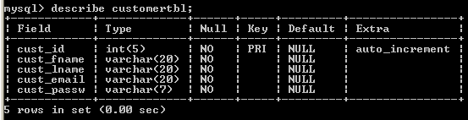
The above table will store the various customer members.

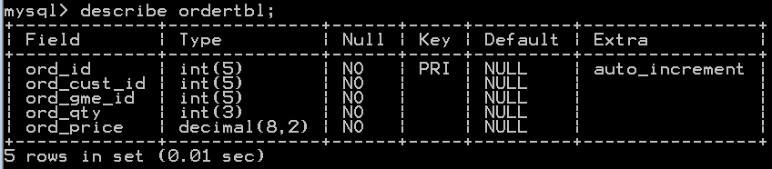
The above table will store the various orders made by the customers.

The following are some sample data for each table (you can change/add your own)
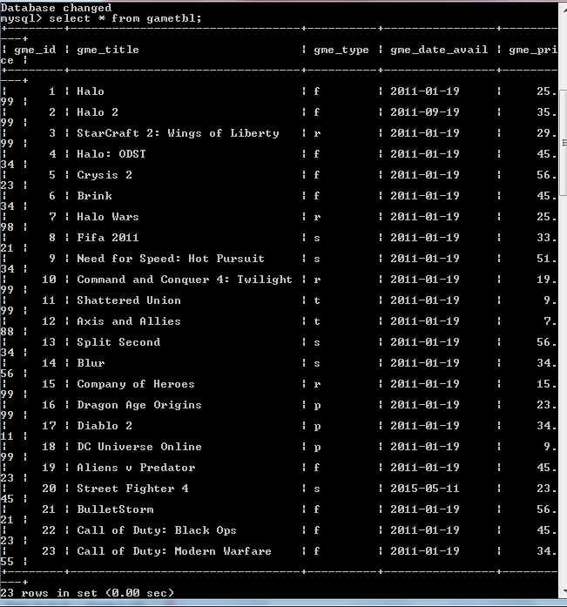

Note: Make at least one game title currently NOT available (like Street Fighter 4, not available until May 11th this year). However, if you went to the wamp site AND the date has turned 2015-05-12, then that game should be available.

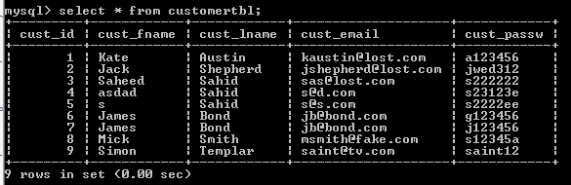
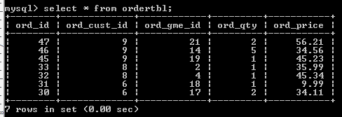

Other Programs
Feel free to create other PHP programs as you require it. (You may want to do one for “cookies”)

Saving the Database

When you create the “gamebuydb” database, the default storage engine for each table may be “InnoDB”. Please convert the storage engine to “MyISAM”,
To do this in phpMyAdmin

- Load up phpMyAdmin
- Click on “gamebuydb”, i.e.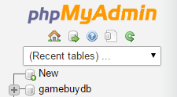
- Click on the first table, “customertbl”, i.e. 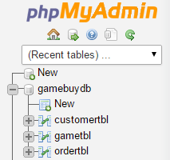

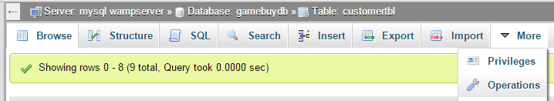

- Select “Operations” from

- Select “MyISAM” from Storage Engine
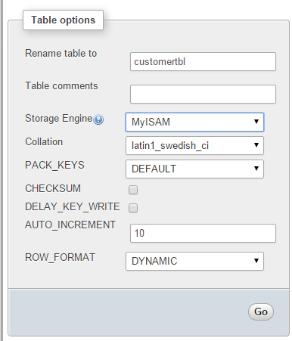

- Click the corresponding “Go” button

- Repeat this for all your gamebuydb tables.

If you check your “gamebuydb” folder in wamp, i.e. 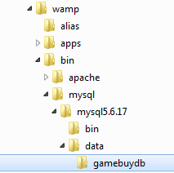, you should have:
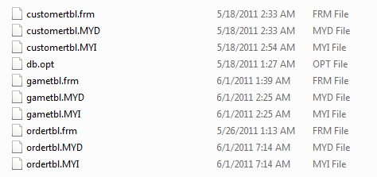
You can now backup your entire database, just by copying that gamebuydb folder.

What to hand in:
- Front cover page with your name (your partner’s name), course, assignment number, instructor’s name, section and due date. (If you did this assignment with a partner, then hand in ONE piece of work with BOTH your names on it).
- Hardcopy of the program listing.
- Zip up the web page ,php program and mySQL database, and save as
csis3280-01W2015YourNameAs4.zip and do a file submission through myDouglas

Please Note, for the mySQL database, give me the actual database itself from the
“wamp\bin\mysql\...\data\” folder (rather than any mySQL script)

MARKS WILL BE LOST IF ANY OF THE ABOVE IS NOT MET OR IF THIS IS NOT YOUR OWN WORK

